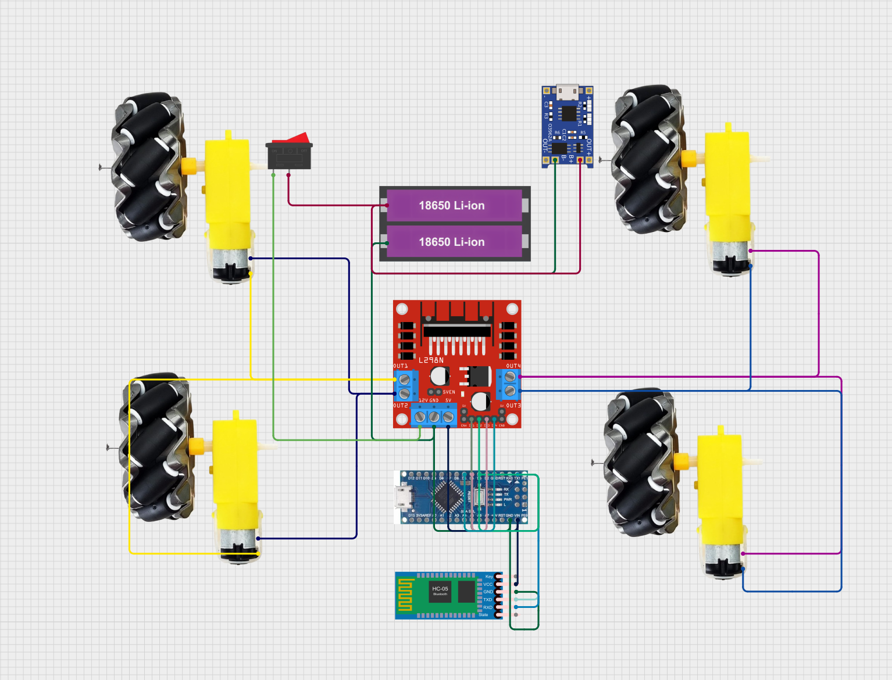

BLUETOOTH CONTROLLED ROBOT [CIRCUIT DESIGN]

BLUETOOTH MODULE

GEAR MOTOR 4

GEAR MOTOR 3

ARDUINO NANO

L298N MOTOR DRIVER

CHARGING MODULE

7 VOLT LION BATTERY

SWITCH

GEAR MOTOR 2

GEAR MOTOR 1